It is certified that Annual Quality Assurance Report (AQAR) for the Session 2017-18 could not be prepared & submitted due to some unavoidable reasons.

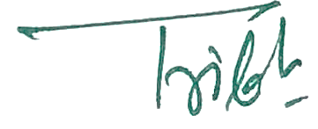
Principal

